Day 4
Task 1: Method overloading.
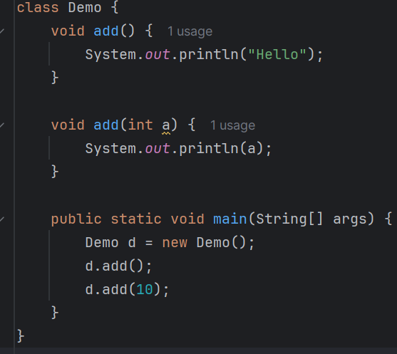
Task 2:
History of Java?
Java is a high-level language developed by James Gosling at Sun Microsystems in 1991. It is a platform independent language means no need of changing code when it is changed from on operating system to other OS.
Java programs can run on any operating system that has a Java Virtual Machine (JVM).
Task 3:
LinkedList curd basic operations
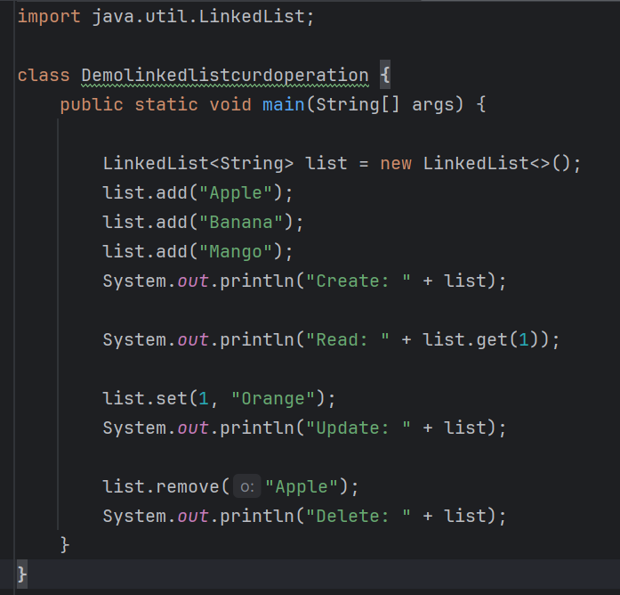

Swapping numbers:
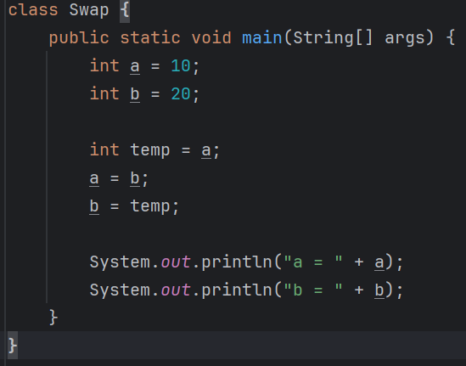
Task 4:
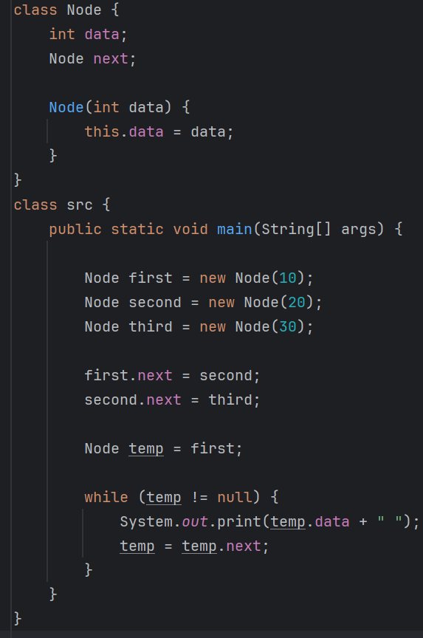

Task 5:
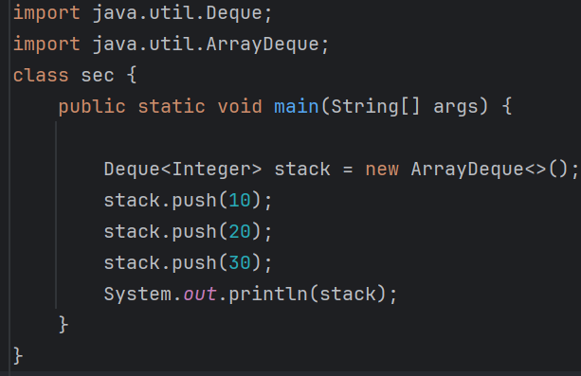
Task 6:
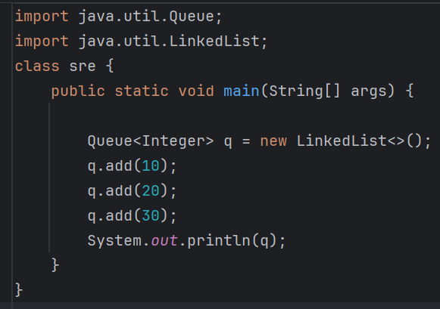
Task 7: Method overriding
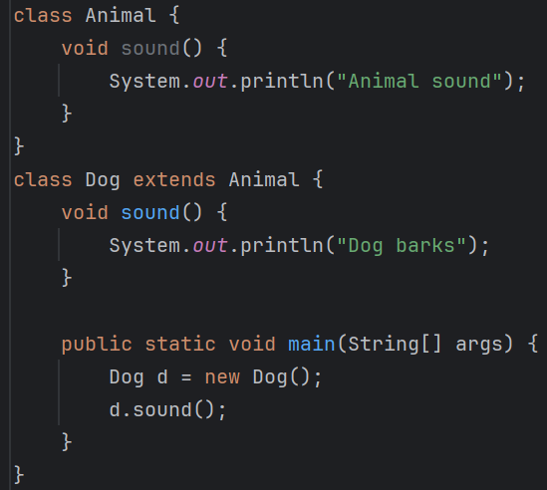
Task 8: Advantages of polymorphism?
Polymorphism allows one method or interface to perform different actions based on the object, which improves flexibility and code reusability. It reduces code duplication and makes programs easier to maintain and extend.
Task 9:
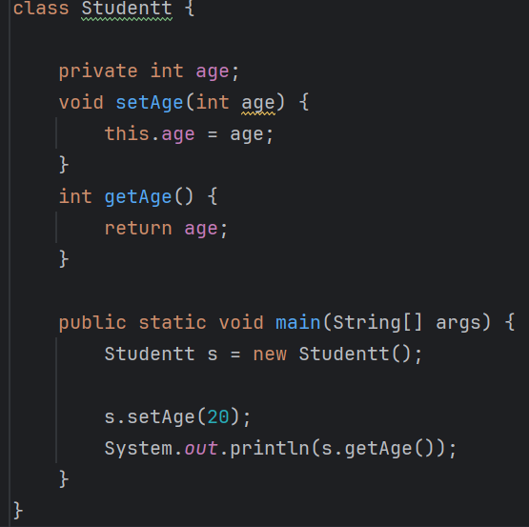
Task 10:
Advantages of Encapsulation: Encapsulation provides data security by hiding data from direct access, improves code maintainability, and allows controlled access through methods.
Disadvantages of Encapsulation: Encapsulation requires additional code for getters and setters and can increase program complexity.

Task 11:
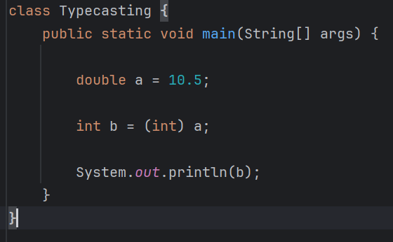
Task 12:
Autoboxing - Is the automatic conversion of a primitive data type into its corresponding wrapper class object.
Auto-unboxing - Is the automatic conversion of a wrapper class object back into its corresponding primitive data type.

